04.05 Quality Auditing
Process Design & AMOS Configuration Document
Purpose
This Process Design document is provided to Key-Users to record their key decisions regarding the AMOS Process design and the required AMOS configuration.
It is updated throughout the Project Definition Phase and used as the baseline for the Final Acceptance prior to Go-Live
Revision
Author, Name | Date | Notes
Jakub Sadowski | 01.12.2024 | Edition 24.12, additional information included in process diagram

Table of Contents
1. Process Overview & Objectives 3
2. Regulatory References 3
3. Definitions & Glossary 3
4. Process Tasks 4
5. Process Dependencies 4
6. Process Flow 5
7. Process Design Questions 6
8. Data Source Mapping 7
9. Other Software Used 7
10. AMOS Configuration 8
a. Process specific configuration programmes 8
b. Basic Data 8
c. Parameters 8
d. Workflows 8
e. Scheduled Tasks 9
f. API’s & Interfaces 9
11. UAT Guidance 9
12. Annex – Additional Info 9

Process Overview & Objectives
Process General Description:
Quality Auditing with AMOS is a powerful tool to define audit questions, a list of questions for a specific audit or a specific organization (internal or external) and to handle audit findings, answers and suggested actions within AMOS.
It is as well possible to use Quality Auditing with AMOS company wide even for non technical departments, because the system is completely configurable.
Main Process Objective (Outputs & Outcomes):
Creation of QA Schedule
Execute internal audit plan

Regulatory References

Regulation (EU) 2015/1536 M.A.712 Quality system
(a) To ensure that the approved continuing airworthiness management organisation continues to meet the requirements of this Subpart, it shall establish a quality system and designate a quality manager to monitor compliance with, and the adequacy of, procedures required to ensure airworthy aircraft. Compliance monitoring shall include a feedback system to the accountable manager to ensure corrective action as necessary.
(b) The quality system shall monitor activities carried out under Section A (...)
Regulation (EU) 2015/1536 145.A.65 Safety and quality policy, maintenance procedures and quality system
(c) The organisation shall establish a quality system that includes the following:
1. Independent audits in order to monitor compliance with required aircraft/aircraft component standards and adequacy of the procedures to ensure that such procedures invoke good maintenance practices and airworthy aircraft/aircraft components.
2. A quality feedback reporting system to the person or group of persons specified in point
145.A.30(b) and ultimately to the accountable manager that ensures proper and timely corrective action is taken in response to reports resulting from the independent audits established to meet point (1).

Definitions & Glossary
Key-Words | Explanation
Audit Location | The physical place where the audit is conducted
Auditee | Person, group or organization which is audited by auditor
Category | Under which category (Ground, Flight, Technical…) is the audit conducted
Chapter | chapters of your manuals, which the compliance against will be audited
Checklist | Defined List of Questions for the Audit
Item-Pool | Table of all questions entered into the system
Lead Auditor | Person who leads the audit (responsible for audit report and follow-up, therefore usually also for entering data in AMOS)

Process Tasks

Creation of Audits and Audit Time Plan – using APN 416 a Compliance Monitoring Manager or other delegated employee may create required types and instances of Audits and plan their execution with graphical representation of the schedule in calendar view.

Question Bank Creation & Update – Responsible personnel is able to access, create and update a repository of QA questions using APN 478

Execution of audit, creation and follow-up for audit findings - APNs 472, 506 and 416 are used to execute audits and raise NCs, follow-up on them, and finally close the audits.

Process Dependencies
INPUT | CONCURRENT | OUTPUT
- 00.01 Application Configuration  - 00.02 Users & Roles  - 04.01 Company Organization | 00.04 Scheduler Tasks

Process Flow
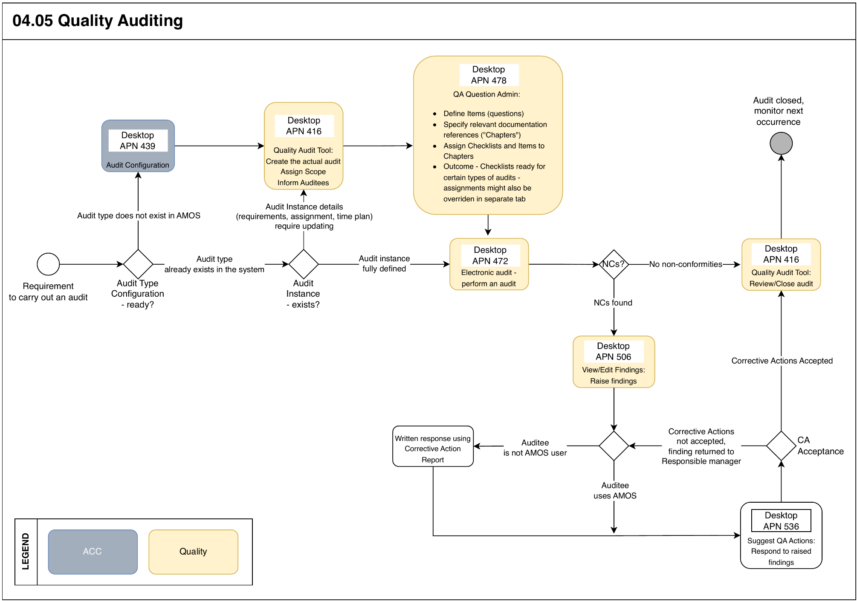

Process Design Questions
# | Question | Answer
 | Do you currently use a system to manage quality audits? If yes, what kind of system are you currently using?
 | Do you intend to use AMOS as a primary tool for auditing or will limit its use to aspects related to Maintenance / Airworthiness?
 | Who will be performing quality audits in AMOS?
 | Do you consider quality inspections, apart from quality audits, to be a part of your annual schedule? Are such inspections also conducted by Auditors, or delegated to technical/executive staff?
 | Are there external parties involved in audit activities (3rd party audits) who would need to access the system and perform audits using AMOS?
 | What kinds/categories of audits would you like to distinguish?
 | Do you handover a list of questions to the audited person, and enter the result yourself in the recording system?
 | Will you use a random questions list generated automatically?
 | Is Safety Management System interacting in any way with Compliance activities? How are MSR (Maintenance Safety Report), GSR (Ground Safety Reports, ASR (Air Safety Reports) handled?
 | How do you record findings and action items?
 | How do you follow up corrective action items? How are they tracked?
 | How many levels of finding would you like to set? Do you rise Observations / Opportunities for Improvement? Are Observations mandatorily actionable?

Data Source Mapping
Data Sources | Description | Volume / Manual / Automatic / Static / Dynamic
-/- | -/- | -/-

Other Software Used
Other Software | Used by: | Description
-/- | -/- | -/-

AMOS Configuration

Process specific configuration programmes
AMOS APN | Notes
APN: 14 Admin Logins | Define the user logins and assign them to user roles.
APN: 15 Admin Roles | Define user roles and assign access rights (licenses) to each of them.
APN: 53 Address Administration | Create addresses which will be associated with Audit Locations.
APN: 146 Staff Management | Define employee data. Link each employee to Financial entity.
APN 416: Quality Audit Tool | Creation of Audit Time Plan
APN 439 Audit Configuration | Set audit locations, audit categories, finding types, priority types, documents tree (chapters), dictionaries of Root Causes and Action Implemented, finally – Checklists
APN: 2111 Approval Control Configuration | Configure the rules for approval of invoices / credit notes / debit notes, according to applicable Delegation of Authority / Limits of Authority policy of the organisation.

Basic Data
Basic Data Table | Notes
N/A

Parameters
Parameter Code | Parameter Name | Notes
1345 | QA: CORRECTIVE ACTION FORM NUMBER | This Parameter is only valid for NEOS reports. You can enter here a form number for the Corrective Action Report as string.
1351 | QA: CHECKLIST - FORMNUMBER | This Parameter was only valid for NEOS reports.

Workflows
Workflow Number | Workflow Name | Workflow Setup Notes
174 | Suggested QA Action Workflow | Workflow to manage Suggested QA Actions in Quality Audit Tool.
199 | Suggestion Rejection Workflow | Workflow that is triggered when a suggestion is rejected in quality audit tool.
232 | Finding Due Date Workflow | Workflow to manage Finding Due Dates in Quality Audit Tool. The workflow itself is triggered over the scheduler task QaFindingDueDateReminder

Scheduled Tasks
Scheduled Task Reference | Frequency | Notes
QaFindingDueDateReminder | As required

API’s & Interfaces
Reference | Direction | Trigger | Frequency
No interfaces related to QA

UAT Guidance
Test case number | Test case description | Required data | Required resources
T04.05.01 | Create an audit and sample questions
T04.05.02 | Audit execution, incl. raising non-conformities
T04.05.03 | NC response
T04.05.04 | Audit closure

Annex – Additional Info
-/-

